## EXPERIMENT 6

**AIM: Write an ALP to perform the logical operation 16 bit number using DYNA 8086 kit**

**THEORY:** (Explain in short about logical instructions used in Program )

**ALGORITHM**:

1. Initialize SI to input the Source String.
2. Initialize DI to store the Destination String.
3. Load AX & BX with first & second number.
4. Perform logical operations and operations & transfer the result in memory.
5. Terminate the program.

### 

PROGRAM AND EXECUTION SCREENSHOT:

8BIT

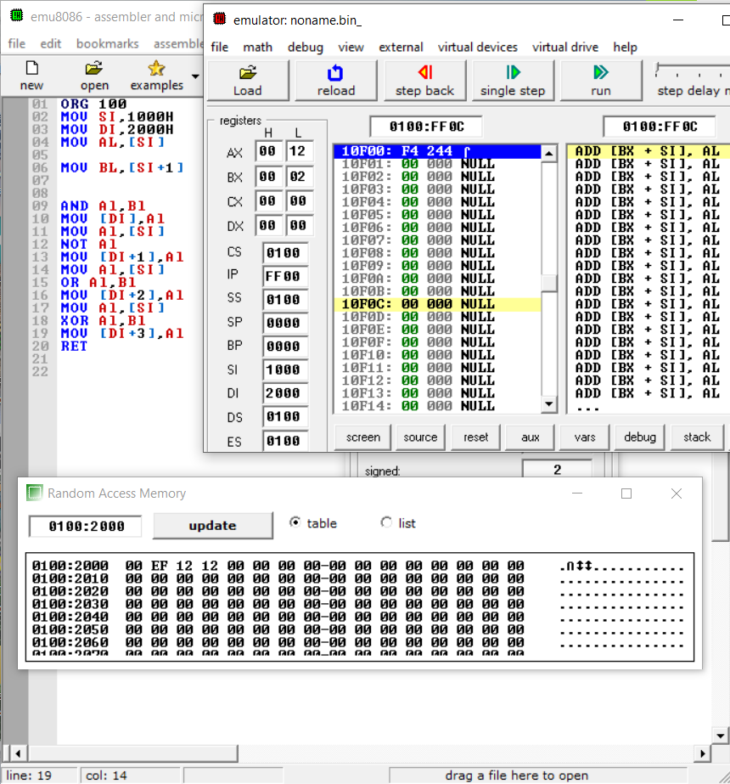

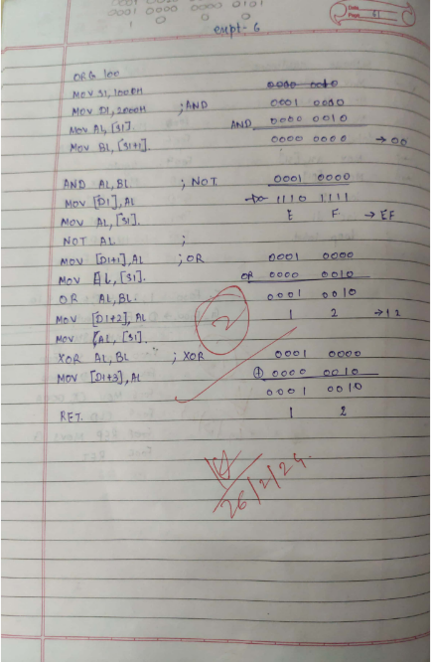

16BIT

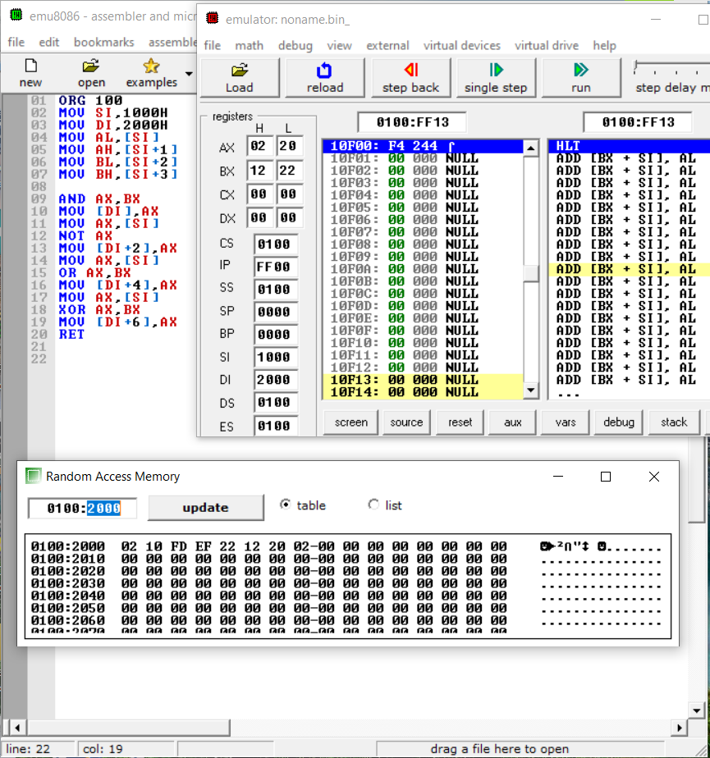

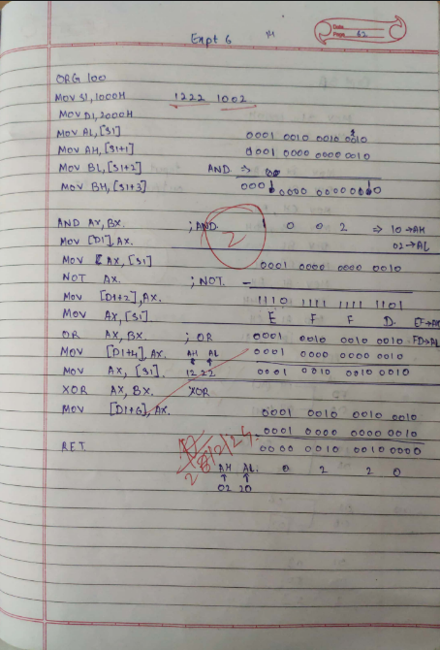

**CONCLUSION**:

Name :

Roll No:

Batch :